
Banyule District Cub Scouts

District Event!
Sunday the 14th of October

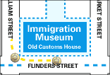
Immigration Museum

Old Customs House

400 Flinders Street, Melbourne

We will be gathering at 10.45 for an 11.00am Tour
Finishing around 1.00pm

Celebrating World Cultures through Scouting
Take a new look at the Scouts in this exhibition highlighting their role in sponsoring and settling thousands of young migrants since 1913.
Providing a forum for learning about Australia's culture and great outdoors, and offering friendship and support, the Scouts have welcomed new arrivals from all over the world.
Presented in the Immigration Museum's Community Gallery, the exhibition explores the personal stories of child and adolescent migrants to Victoria who found a new community through Scouts, and the impact of this association on their lives.
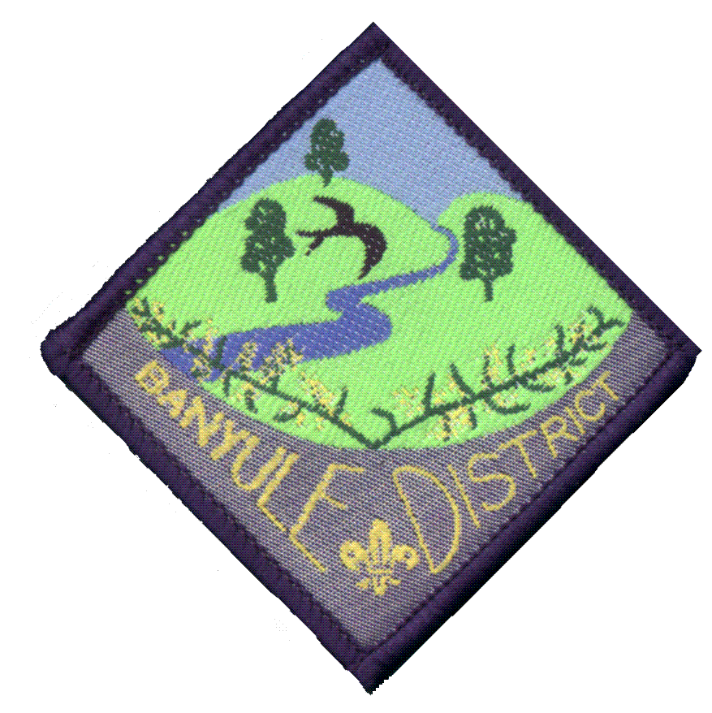General Admission
Adults $6.00
Children* and Concession Free.
Free admission to the ground floor.
Disabled access & facilities available.
* Children 3-16 years inclusive.
Bring Lunch, Drink Bottle
Train Ticket (Sunday Saver)

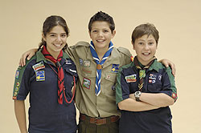
Information
Located in the Old Customs House in the heart of the city, the Immigration Museum explores stories of people from all over the world who have migrated to Victoria from the 1800s through to the present day. Stories are brought to life through moving images, computer interactives, voices, memories and belongings. The result is an entertaining experience that engages the senses.

Full Uniform to be worn
Banyule District Cub Scouts

Ticket Details:
Sunday Saver Metcards
allow unlimited train, across Zones 1 and 2 on Sundays for only $2.50.

Train Details:
Departing
Rosanna Railway Station (Rosanna) | 9:58am
Flinders Street Railway Station (Melbourne City) | 10:26am

Lunch (Bring Your Own)
Birrarung Marr, alongside the Yarra River in the heart of the city.
Birrarung Marr
Opened in January 2002, Birrarung Marr is Melbourne’s first new major parkland in more than 100 years. Located on the banks of the Yarra River, the park’s name is from the language of the Wurundjeri people – ‘Birrarung’ means ‘river of mists’ and ‘Marr’ equates to ‘side’. Large sculptured terraces planted with native flora and 200 new trees form a theatre-like space designed to accommodate large crowds for festivals and performances. The park creates an almost continuous green belt of parkland around the city, and its pathways and bike tracks link the city centre and Federation Square with the Sports and Entertainment Precinct. Its attractions include Speakers Corner, which makes for great oratory entertainment and Federation Bells, a stunning field of 39 electronic bells, which ring daily. The park also features ArtPlay, an old railway building used as a children’s creative facility and gallery, along with a modern outdoor playground with a variety of physical and sensory components to stimulate children’s creativity.

Returning
Flinders Street Railway Station (Melbourne City) | 2:08pm
Rosanna Railway Station (Rosanna) | 2:40pm

